Author Biography for

Steven Furtick
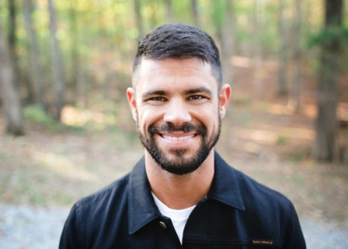
Pastor Steven Furtick is the founder and lead pastor of Elevation Church in Charlotte, N.C., named by Outreach magazine as one of the fastest growing churches in the nation with 20,000 weekly attendees across multiple locations.
Furtick grew up in Moncks Corner, S.C., where, at age 16, he felt God’s call to start an innovative church in a metropolitan city. This vision became a reality in 2006 when Furtick, along with his wife, Holly, and seven other families, moved to Charlotte and launched Elevation Church. In 10 years, the church has given away over $20 million to local outreach organizations, opened 13 locations, released eight worship albums, launched a daily television program, and continues to reach thousands of people with the hope-filled message of the Gospel.
In his fourth book, (Un)Qualified: How God Uses Broken People To Do Big Things (March 1, 2016, Multnomah Books), Furtick confronts the question of what it means to be deemed “qualified”—whether in ministry, vocation, or life. He untangles the difference of being qualified by God’s definition versus the world’s definition.
“I have to admit, this hasn’t been an easy book to write. It’s not that the topic is particularly controversial. It’s been hard to write because it’s messy,” says Furtick.
“If you’ve ever been frustrated by your failures or exasperated by your weaknesses, this book is for you,” he continues. “But let me warn you, I’m not going to tell you 15 ways to fix yourself in 15 minutes a day. I want to do something that is, I hope, a lot more valuable. I want to be real.”
Furtick is also the author of the New York Times best-sellers Crash the Chatterbox (Multnomah Books, 2014) and Greater (Multnomah Books, 2012). His debut book Sun Stand Still (Multnomah Books, 2010) calls Christians to activate their faith and be inspired to ask God for the impossible. In addition, he created the DVD and study guide Seven Mile Miracle (Feb. 2013) about the last words of Christ.
Furtick has had the privilege to speak to global audiences at such conferences and churches around the world as the Catalyst Conference, Hillsong Conference and the Willow Creek Global Leadership Summit.
Furtick received a B.A. in communications from North Greenville University and a Master of Divinity from Southern Baptist Theological Seminary. He and his wife, Holly, have two sons and a daughter.
For further information, visit www.stevenfurtick.com, www.iamunqualified.com or www.waterbrookmultnomah.com.
Facebook: https://www.facebook.com/StevenFurtick
Twitter: @stevenfurtick

For review copies or questions, contact Beverly Rykerd at brykerd@penguinrandomhouse.com or
(719) 268-1935.

