Author Biography for
STEVEN FURTICK
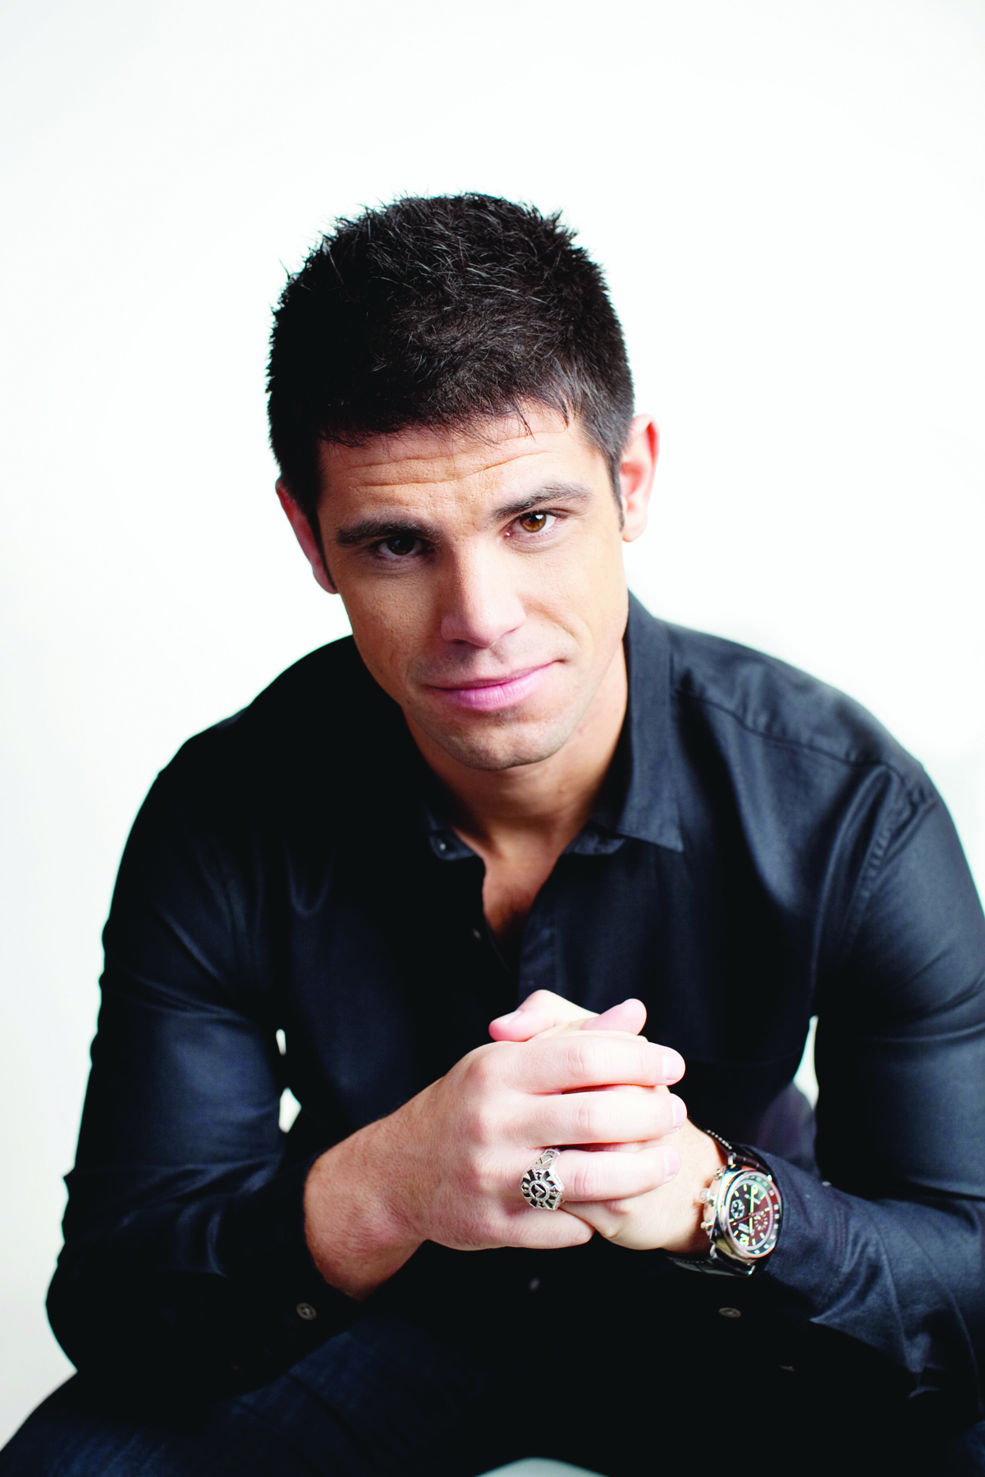
Pastor Steven Furtick is the founder and lead pastor of Elevation Church in Charlotte, North Carolina. He and his wife, Holly, have two sons, Elijah and Graham, and daughter, Abbey. They make their home in the Charlotte area.

Steven grew up in Moncks Corner, South Carolina, where at age 16 he felt God’s call on him to start a life-changing church in a metropolitan city.

This vision became a tangible reality when Elevation was founded on the faith of eight families who risked everything, selling their houses and quitting their jobs, to start a church. They moved to Charlotte believing that God would turn this city upside down for His glory through the local church.

In less than a decade, Elevation Church grew to more than 18,000 in attendance each week, meeting at nine locations in the Charlotte area, as well as one location in Toronto, Canada. The church has consistently been named one of the “Fastest-Growing Churches in America” by Outreach Magazine for each of the past seven years.

Steven attended North Greenville University, received a B.A. in communications and went on to complete a Master of Divinity from Southern Baptist Theological Seminary.

Steven is the author of Sun Stand Still (Multnomah Books, 2010), a book that calls Christians to activate their faith and be inspired to ask God for the impossible. His second book, the New York Times best-seller Greater (Multnomah Books, 2012), calls believers to stop settling for good-enough mediocrity or wishing for personal greatness, but to allow Christ in them to do “greater” things in and through their lives. In his most recent book, and his second New York Times best-seller, Crash the Chatterbox (Multnomah Books, Feb., 2014), Furtick addresses the widespread problem of negative and destructive self-talk—a phenomenon he calls the “Chatterbox.” Furtick shares personal examples and lessons from Scripture that have been helpful to him in defeating damaging internal dialogue.

His newest release, Greater Devotional (Multnomah Books, Sept. 9,2014), is a companion to his New York Times best-seller Greater. The Greater Devotional is a motivating, 40-day plan to escape "good enough" and take your dream from idea to implementation. Furtick applies the message from Greater in practical, inspiring daily readings.
For an interview or review copy, please contact Beverly Rykerd, brykerd@penguinrandomhouse.com or 719/268-1935.

WaterBrook Multnomah Publishing Group
12265 Oracle Blvd., Ste 200, Colorado Springs, CO 80921 www.waterbrookmultnomah.com/press-room

