For Immediate Release  from Multnomah Books  a division of Random House, Inc. | Contact: Beverly Rykerd  brykerd@randomhouse.com  (719) 268-1935

FURTICK KICKS OFF NEW BOOK WITH
CRASH THE CHATTERBOX LIVE! RADIO EVENT

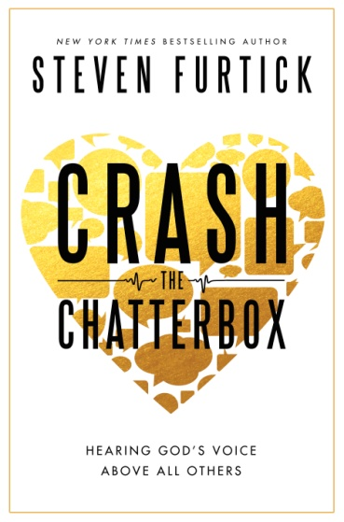
COLORADO SPRINGS, Colo.,—(February 10, 2014) Steven Furtick, one of the country’s young, influential Christians leaders as lead pastor of North Carolina’s largest church, is hosting a special, live, day-long radio event on Tuesday, February 11 at www.elevationnetwork.com to coincide with the release of his new book Crash the Chatterbox: Hearing God’s Voice Above All Others (Multnomah Books, Feb. 11, 2014).

Furtick, founder and lead pastor of Elevation Church and a New York Times best-selling author, taps into the theme of chatter, or dialogue, by spending 10 am to 6 pm ET talking with special guests and callers about the lies that we tell ourselves and how to overcome them. Every hour will feature a special guest to include:
- Lysa TerKeurst, president of Proverbs 31 and best-selling author of Made to Crave
- Pastor Craig Groeschel, lead pastor of LifeChurch.tv
- Steve Smith, Pro-Bowl wide receiver of the Carolina Panthers
- Grammy-award winning singer Mandisa
- Louie Giglio, founder of The Passion Movement, Passion Church and best-selling author
- Shaunti Feldhahn, best-selling author of The Surprising Secrets of Highly Happy Marriages
- Christine Caine, popular speaker, founder of A21 and author of Undaunted
- Musician Israel Houghton, a Grammy-award winner
- Carl Lentz, pastor of Hillsong NYC
- MMA #1 Contender Vitor Belfort
- Kari Jobe, Dove-awarding and Grammy nominated artist
- And more

Furtick, his special guests and callers will tackle the core issues in Crash the Chatterbox, such as insecurity, fear, discouragement, condemnation and the truths in God’s word that can short-circuit them. Sharing from personal experience, Furtick and friends will touch on how these topics show up in day-to-day life, such as parenting, marriage, leadership, work and church.

-more-
Regarding his own experience with negative thoughts, Furtick writes in Crash the Chatterbox: “I used to think that someone who struggled with the kinds of weaknesses I deal with daily was useless to God. I felt so often like I was drowning in internal dialogue I couldn’t control. It had been the soundtrack of my life for as long as I could remember. Yet everything changed when I began to realize God has given us the ability to choose the dialogue we believe and respond to. And once we learn how, we can switch from lies to truth as deliberately as we can choose the Beatles over Miley Cyrus on satellite radio.”

The Crash the Chatterbox Live! radio event will be available online at desktops, mobile devices, or the Elevation App.

ABOUT THE AUTHOR: Steven Furtick is the founder and lead pastor of Elevation Church in Charlotte, N.C., which since its founding in 2006 has grown to more than 14,000 weekly attendees at 11 locations. He is the author of the New York Times best-seller Greater (Multnomah Books, 2012) and the popular Sun Stand Still (Multnomah Books, 2010). He holds a Master of Divinity degree from Southern Baptist Theological Seminary. Furtick and his wife, Holly, have three young children Elijah, Graham and Abbey.

For more information, visit www.crashthechatterbox.com, www.stevenfurtick.com or www.elevationnetwork.com. Press information is available at www.waterbrookmultnomah.com/press-room.

# # #

Category: Christian Living
ISBN 978-1-60142-456-3 ● Hardcover ● 240 Pages ● $19.99 U.S./$22.95 Canada
eBook: ISBN 978-160142-458-7
DVD: ISBN 978-1-60142-658-1● $25.99/ $28.95

