For Immediate Release  from Multnomah Books  a division of Penguin Random House, LLC. | Contact: Beverly Rykerd  Publicity Manager  719-268-1935  beverly@randomhouse.com

Noise-Cancelling Headphones for Negative Self-Chatter
Furtick Teaches How God’s Promises Turn Down Volume on Lies We Tell Ourselves

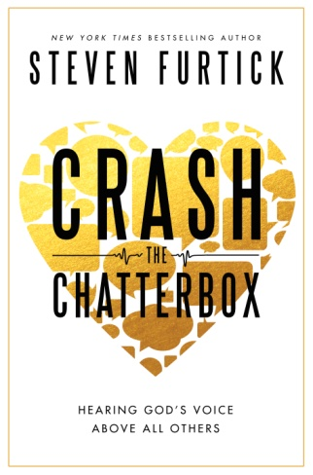
Nobody wants to be around me… I’m not good at anything... I’m such a disappointment... Nothing looks good on me...

If any of these statements sound familiar, then you are acquainted with what Pastor Steven Furtick calls “the chatterbox”—the negative thoughts that make it difficult to listen and respond to God’s voice. In Crash the Chatterbox: Hearing God’s Voice Above All Others (Multnomah Books, February. 11, 2014), New York Times best-selling author Furtick offers help to overcoming damaging internal dialogue and replacing it with God’s truths.

Writing from a place of personal experience blended with a study of Scriptures, Furtick teaches four “confessions” that offer a reminder of God’s promises and short- circuit destructive mental static:
- God says I am—overpowering the lies of insecurity
- God says He will—overpowering the lies of fear
- God say He has—overpowering the lies of condemnation
- God says I can—overpowing the lies of discouragement

“I’m now awakening to the reality that we can access the power of God’s promises to constantly crash the system of our broken beliefs,” writes Furtick. “I’m learning how to overpower the shout of the Enemy by bending my ear to the whisper of God’s supernatural truths about my identity in Him and His strength in me.”

Fast-paced, rooted in Scripture, and thought-provoking, Crash the Chatterbox delivers a message that is needed by anyone—whether in the pulpit or the pew—who has doubts, fears, insecurities or disappointments. No one is immune from the chatterbox, and it is not a “one and done” battle.

“Chatterboxing is a full-time occupation, because the chatterbox takes no breaks and takes no prisoners,” Furtick says. “…You can sabotage it. You can subvert it. But you cannot silence it. …Here’s the good news: When you’ve defeated the chatterbox once, you have the capacity to beat it every time. The key is persistence.”

To assist in further learning, a six-part companion “Crash the Chatterbox” DVD and study guide are available and can be adapted into four, five or six programs for group or individual use. Employing drama, comedy and Furtick’s insightful teaching, the video lessons offer new understanding and strategies to overcome the Chatterbox at home, at work, at church, on campus or in a community.

For more information visit, www.crashthechatterbox.com or the online press room at www.waterbrookmultnomah.com/press-room.

ABOUT THE AUTHOR: Steven Furtick is the founder and lead pastor of Elevation Church in Charlotte, N.C., which since its founding in 2006 has grown to more than 14,000 weekly attendees at 11 locations. He is the author of the New York Times best-seller Greater (Multnomah Books, 2012) and the popular Sun Stand Still (Multnomah Books, 2010). He holds a Master of Divinity degree from Southern Baptist Theological Seminary. Furtick and his wife, Holly, have three young children Elijah, Graham and Abbey. www.stevenfurtick.com
Category: Christian Living
ISBN 978-1-60142-456-3 ● Hardcover ● 240 Pages ● $19.99 U.S./$22.95 Canada
eBook: ISBN 978-160142-458-7
DVD: ISBN 978-1-60142-658-1● 25.99 $28.95

