Author Biography for

Steven Furtick

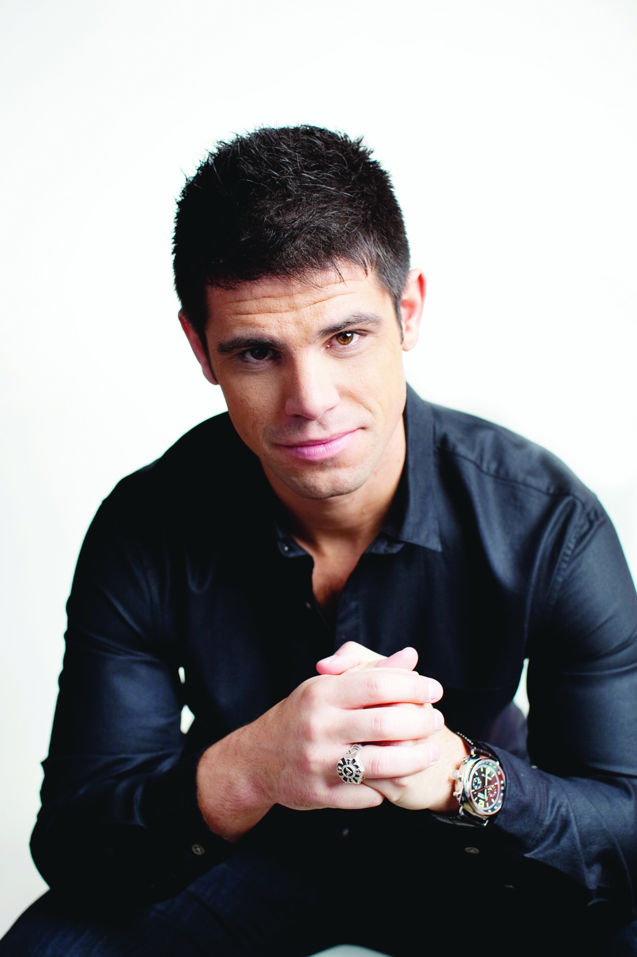
Pastor Steven Furtick is the founder and lead pastor of Elevation Church in Charlotte, N.C., named by Outreach magazine as one of the fastest growing churches in the nation. Since its founding in 2006, it has become North Carolina’s largest church with 14,000 weekly attendees at 10 locations in the Charlotte area and one in Toronto, Canada.
Furtick grew up in Moncks Corner, S.C., where at age 16 he felt God’s call on him to start a life-changing church in a metropolitan city. This vision became a tangible reality when Elevation was founded on the faith of eight families who risked everything. Selling their houses and quitting their jobs, they moved to Charlotte believing that God would turn this city upside down for His glory through the local church.
In his third book, Crash the Chatterbox: Hearing God’s Voice Above All Others (Multnomah Books, February 11, 2014), Furtick addresses the widespread, nearly universal, problem of negative and destructive self-talk—a phenomenon he calls the “Chatterbox.” No stranger to boxing with the Chatterbox himself, Furtick shares personal examples and lessons from Scripture that have been helpful to him in defeating damaging internal dialogue.
“I used to think that someone who struggled with the kinds of weaknesses I deal with daily was useless to God,” writes Furtick. “I felt so often like I was drowning in internal dialogue I couldn’t control. It had been the soundtrack of my life for as long as I could remember. …Yet everything changed when I began to realize God has given us the ability to choose the dialogue we believe and respond to. And once we learn how, we can switch from lies to truth as deliberately as we can choose the Beatles over Miley Cyrus on satellite radio.”
Furtick is also the author of the New York Times best-seller Greater (Multnomah Books, 2012), in which he calls believers to stop settling for good-enough mediocrity or wishing for personal greatness, but to allow Christ in them to do “greater” things in and through their lives. His debut book Sun Stand Still (Multnomah Books, 2010), calls Christians to activate their faith and be inspired to ask God for the impossible. In addition, he created the DVD and study guide Seven Mile Miracle (Feb. 2013) focused on the last words of Christ.
Furtick has been privileged to speak to global audiences at such conferences and churches around the world as the Catalyst Conference, Hillsong Conference and the Willow Creek Global Leadership Summit.
Furtick attended North Greenville University, received a B.A. in communications and went on to complete a Master of Divinity from Southern Baptist Theological Seminary. He and his wife Holly have two sons and a daughter.
For further information, visit www.stevenfurtick.com, www.crashthechatterbox.com or the online press room at www.waterbrookmultnomah.com/press-room.
For review copies or questions, contact Beverly Rykerd at brykerd@randomhouse.com or
(719) 268-1935.

