Author Biography for

Timothy Lewis
author of Forever Friday

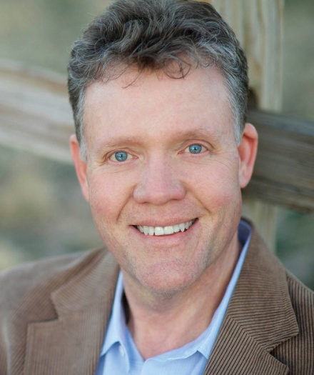
Timothy Lewis is an author and playwright. He has written more than twenty plays/musicals. In addition, he teaches a beginning novel writing class at West Texas A&M University and co-directs a summer writing academy. Timothy is also a professional speaker, cowboy poet, actor and songwriter.

His first romantic novel Forever Friday (WaterBrook Press, Sept. 3, 2013) is inspired by his real great-aunt and great-uncle’s postcards which he discovered in the trash at an estate sale. For sixty years, the author’s uncle sent his wife a weekly postcard with an original poem. Lewis used this tender love story as the jumping off point to create the romantic lead in Forever Friday, Gabe Alexander, who also sends his bride Pearl a weekly postcard and poem.

Lewis wove in other details that mirror the real couple such as meeting on a jitney bus in Houston, Pearl’s prior engagement and the couple’s professions.

Lewis has created a sweeping romantic story that explores such challenging topics as what it takes to make a marriage last, what role hope plays in life and how faith in God underpins it all.

A romantic at heart, Lewis wrote the music for the book’s video trailer. It was originally penned more than 30-years ago when he was engaged to his wife Dinah. Lewis decided to write his own poems for the novel instead of using his uncle’s and included two that he wrote for Dinah. “Two Tiny Shells,” in the prologue, was written shortly after their first date in Galveston. “The Morning of Our Love” in Chapter 13 was adapted from a song he composed for their wedding.

Lewis lives with his wife near Amarillo, Texas.

For more information, go to www.timothylewisbooks.com or www.waterbookmutlnomah.com/press-room.

