Texas Locations in
Forever Friday by Timothy Lewis
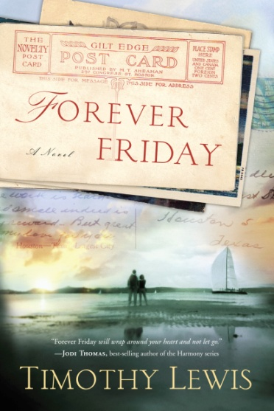
Houston – the main setting. The author did extensive research on the city in 1926. The following landmarks are included in various scenes. These landmarks either exist to this day, or are sites that still hold historical significance to locals and visitors.
a. Market Square – Where Huck shops and Gabe works. Now a popular downtown park. http://marketsquarepark.com/
b. Main Street – Where Gabe walks, and is the main drag in 1926. Now an historic downtown shopping district; it is also site of The University of Houston – Downtown.
c. The Houston Ship Channel – Adjacent to where Gabe works. Includes the historic Buffalo Bayou; connects the Port of Houston to the Gulf of Mexico.
d. The Lancaster Hotel – Where Huck and Gabe spend their honeymoon. Now a small, luxury hotel in the theater district. http://thelancaster.com
e. The Rice Hotel – In Gabe’s thoughts leading up to his explanation of The Long Division. Now downtown lofts with shopping/events; built on site of the Capitol of the Republic of Texas; JFK rested and spoke here on the evening prior to his assassination.
f. The Gulf Building – Where Gabe later works. An art-deco skyscraper; was the tallest building west of the Mississippi when constructed; now the JPMorgan Chase Building.
g. Houston’s Baptist Sanitarium and Hospital – Where Huck learns she’ll never bear children. It is now the Memorial Hermann Healthcare System and part of the famed Texas Medical Center.
h. The Shamrock Hotel – A remembrance Huck shares with Gabe while he’s dying. Demolished in 1987, was the epitome of Texas opulence and flamboyance; swimming pool large enough for exhibition water skiing. The site is now part of the Texas Medical Center.
i. Admiration Coffee/Berings Hardware Store – Huck and Gabe drank Admiration Coffee; Adam and Yvette meet at Berings in the final chapter. It’s now Duncan Coffee, and sold at Berings, and upscale hardware/department store unique to Houston. http://duncancoffee.com/ or http://www.berings.com/

Galveston – Where Huck and Gabe go on their first date, then retrace their steps 21 years later. Again, the author did extensive research wherever he needed to place a scene: Splash Day, the International Pageant of Pulchritude (yes, it really existed), the historic Galveston Seawall, the Strand Shopping District, and Hotel Galvez.

Huntsville – Huck’s childhood home and the site of her secret glen—where she meets Mister Jack—and where she and Gabe attend the Texas Prison Rodeo.

Kilgore – Where Gabe travels alone to work as an accountant during the 1930s East Texas oil boom. Unknown to Gabe, Huck follows, is almost raped, but is rescued by the famed Texas Ranger, El Lobo Solo (the Lone Wolf). El Lobo Solo was an actual Texas Ranger stationed there in the early 1930s to combat epidemic lawlessness. Kilgore is home of the East Texas Oil Museum on the campus of Kilgore College.

Texas City – Where Gabe is almost killed in the 1947 Texas City Disaster, the worst industrial accident in the nation’s history.

