For Immediate Release  WaterBrook Press  a division of Random House, Inc. | Beverly Rykerd, Publicity Manager  719-26-1935  brykerd@randomhouse.com

What Does It Take to Make A Marriage Last?
Debut Romance Explores Universal Question

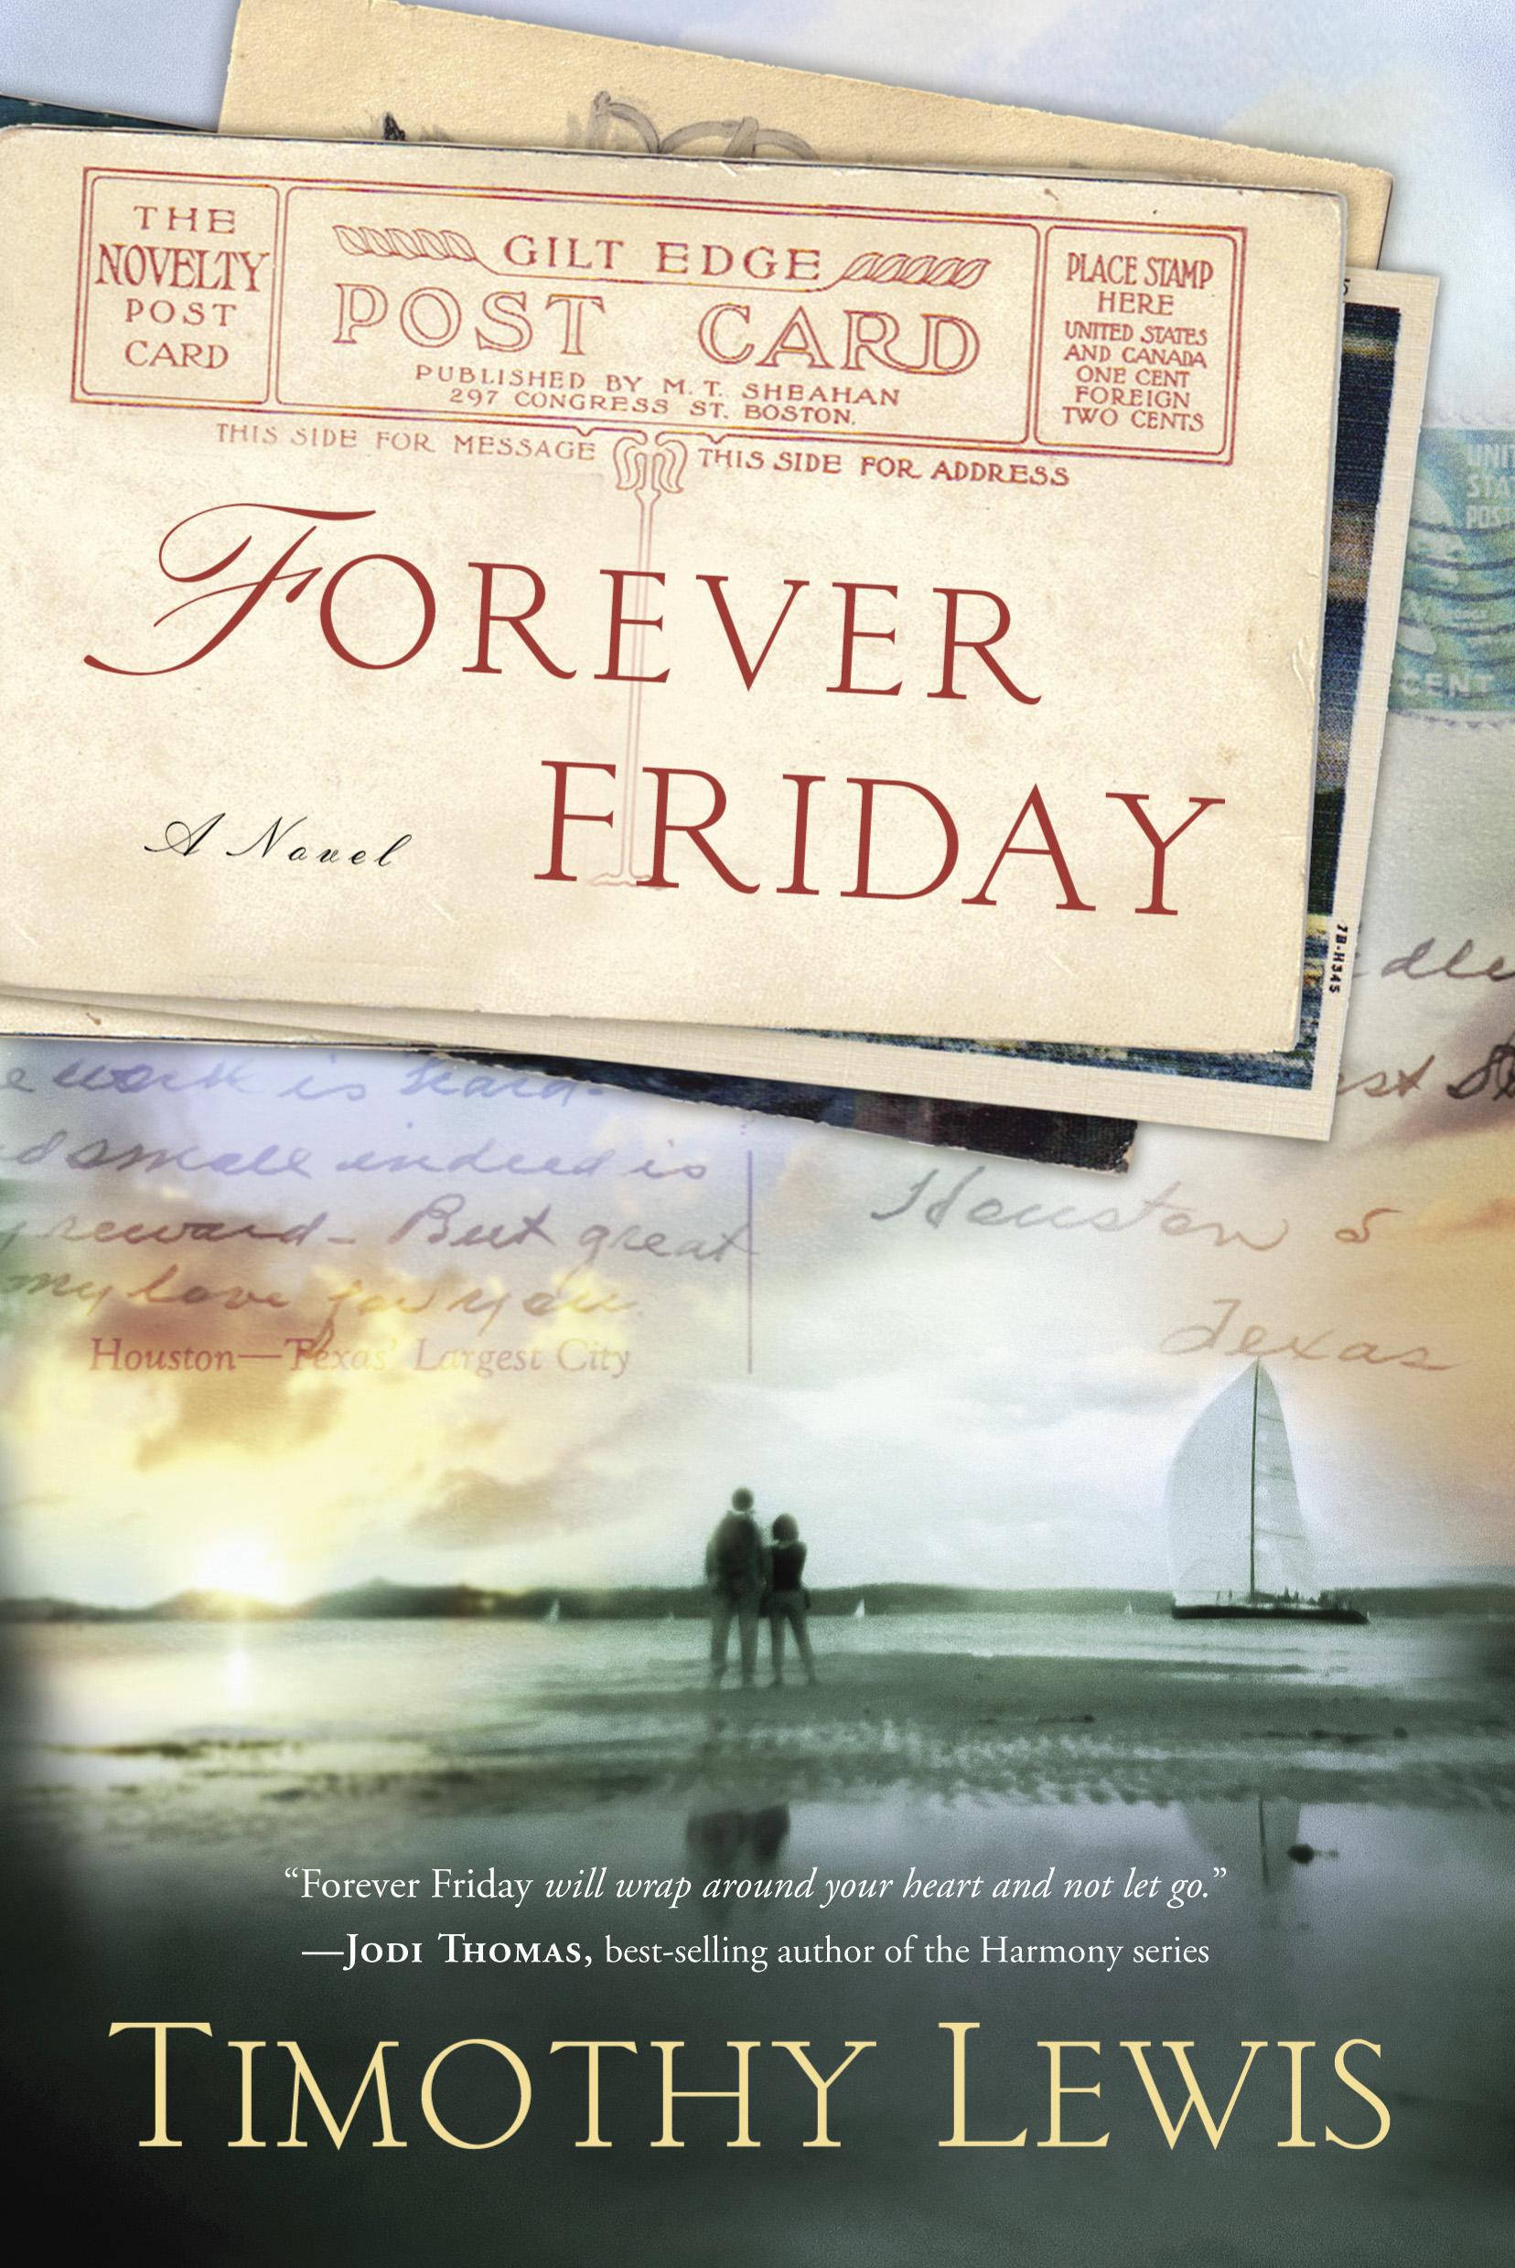
COLORADO SPRINGS, Colo.—Adam Colby had given up on marriage until he found discarded albums of postcards at an estate sale. What Adam discovered was the tender love story between Gabe and Pearl Alexander chronicled in an original poem scheduled to arrive every Friday lasting sixty years of their marriage. Each weekly correspondence holds a precious truth, the sum of which answers the universal question: What makes a marriage last?

Debut romance novelist Timothy Lewis has crafted a sweeping, inspirational story of rare lasting love in Forever Friday (WaterBrook Press, Sept 3, 2013). Lewis takes the reader on a charming trip through 20th century coastal Texas as Gabe and his bride weather the storms of life and a committed relationship which ultimately renews a young man’s hope and faith.

Forever Friday is inspired by the author’s discovery of his real great-aunt and great-uncle’s secret weekly postcards in the trash at their estate sale. He understood he found a real treasure. But it was when a friend going through a divorce called to say he no longer believed in love, Lewis knew he had a story to write.

“From a writing standpoint, I viewed the topic as a challenge,” says Lewis. “There were many, many novels that explored and even touted infidelity but few actually celebrated marriage. From a personal standpoint, I saw what was happening to some of my friends. The day my friend called was eye opening. I couldn’t imagine his not believing in love anymore. I decided to write a novel that might offer ‘hope’ to others going through similar experiences.”
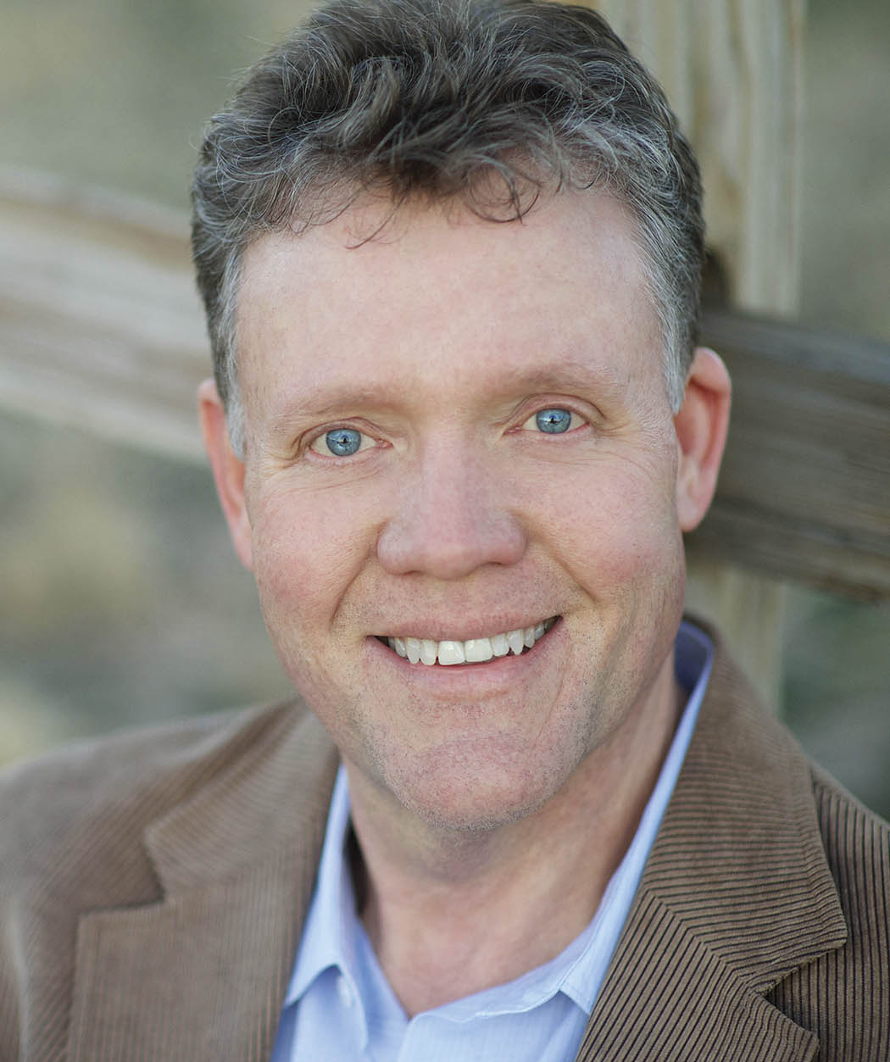
ABOUT THE AUTHOR: Timothy Lewis is an author and playwright. He has authored more than twenty plays/musicals. In addition, he teaches a beginning novel writing class at West Texas A&M University and co-directs a summer writing academy. Timothy is also a professional speaker, cowboy poet, actor, and songwriter. He lives with his wife near Amarillo, Texas. For more information, go to www.timothylewisbooks.com or www.waterbookmutlnomah.com/press-room.

Fiction/Christian/Romance
ISBN: 978-0-307-73221-7 ● Tradepaper ● 288 Pages ● $14.99 U.S./$16.95 Canada
eBook: 978-0-307-73222-4● $9.99 US/ $9.99 Canada

